|  |  |
| --- | --- |
| Names: | Ryan Austin Fernandez, Shayane Tan |

**Problem Analysis (CAI-STA Interview)**

|  |  |  |  |
| --- | --- | --- | --- |
| **Description**  **(What’s the problem?)** | **Cause**  **(What causes the problem?)** | **Symptoms**  **(How do we know the problem exists?)** | **Impact**  **(Why is this important? What are the consequences?)** |
| The current system being used is manual | There is no automated system. | Client uses MS Excel. | This could lead to lack of data integrity or relatively more problems caused by human error. |
| Inconsistencies arise because of the separation of the purchase manager’s system and the technician’s system | There is no centralized database. | There are sometimes discrepancies between the main client’s records and the technicians. | This leads to confusion regarding the final count of each item in inventory. |
| It is currently easy to forget the ends of warranties and contracts manually. | There is no notification feature in Excel. It has to be manually coded into a calendar application, which could be problematic due to the volume of the purchases | Ends of warranties and contracts are overlooked. | Warranties become void, costing the company; contracts end and are not renewed as soon as possible. |
| It Is difficult to keep track of items, their assignees, and the project assignments. | There is no centralized database. | Multiple files have to be accessed in order to find who a certain item is assigned to and for what project/s. | Unneccessary waste of time occurs. |

**Visualize the Process**

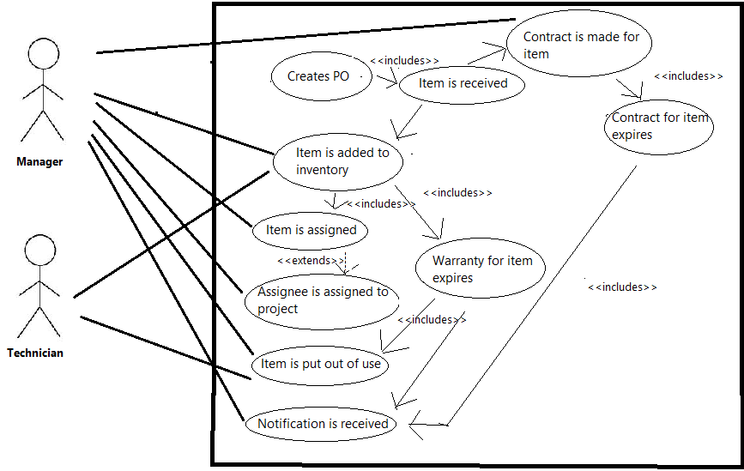

**Figure 1. – Use Case Diagram of the Envisioned System**

**What’s the business goal? Why do they need software?**

The goal is to have a consistent inventory system to keep track of items, the person they are assigned to, and the project the item is being used for, as well as a system to keep track of the purchase orders and contracts related to these items in inventory. Warranty expiries and ends of contracts should also trigger notifications.

Software is needed because the current system being used is manual, which leads to more work, especially in generating reports. Also, inconsistencies arise because of the separation of the purchase manager’s system and the technician’s system. Additionally, it is currently easy to forget the ends of warranties and contracts manually.

**What characteristics should the software have?**

The software should present consistency in records and ease in creating purchase orders, adding items to inventory, and generating the necessary reports. It should have the correct information at all times, to be implemented by using a single database, and it should be maintainable.